2006年全国中学生英语能力竞赛（NEPCS）初赛
初一年级组试题
（总分：150分 答题时间：120分钟）
听力部分（共四大题，计30分）
I. 听辨单词（Words） （共5小题，计5分）
请听句子，从A, B, C, D四个选项中选出你所听到的句子中含有的单词。每个句子只读一遍。（答案涂在答题纸上）
1. A. male B. bell C. sale D. shell
2. A. two B. twelve C. twenty D. ten
3. A. library B. hobby C. story D. family
4. A. chalk B. walk C. talk D. smoke
5. A. mouth B. maths C. mouse D. month
II. 问句应答（Responses） （共5小题，计5分）
请听句子，从A, B, C, D四个选项中选出能最恰当回答所听句子的选项。每个句子只读一遍。（答案涂在答题纸上）
6. A. Oh, don't worry. I won't. B. Of course. Here you are.
C. Thanks all the same. D. Really? Congratulations!
7. A. I think he's nice, and I like him. B. He's fine, thanks.
C. It's OK, but I don't like the teacher. D. Wow, it's a big classroom.
8. A. Good. I'll buy it. B. See you later.
C. You can say that again. D. Sure, sit down, please.
9. A. The one in the blue trousers? B. That's a pity. I'm sorry to hear that.
C. No, not him. The other one. D. It doesn't matter. Go ahead.
10. A. Yes, I watch a little TV. B. No, I don't like watching TV.
C. A lot. I like watching TV very much. D. I have a lot of free time.
III. 对话理解（Dialogues） （共10小题，计10分）
A） 请听五组小对话，根据你所听到的对话内容，选择能回答下列问题的最佳答案。每组对话读两遍。（答案涂在答题纸上）
11. Whose watch is old?
A. Paul's. B. Kate's. C. Jack's. D. Nick's.
12. Where are the black shoes?
A. Behind the blue ones. B. Next to the brown ones.
C. Between the red ones and the brown ones. D. In front of the red ones.
13. What day is Mike's birthday?
A. Tuesday. B. Wednesday. C. Thursday. D. Friday.
14. Which pencil-box does the woman want to buy?
A. The big green one. B. The small orange one.
C. The big orange one. D. The small green one.
15. What are they going to do tomorrow afternoon?
A. Do some shopping. B. Go to the same beautiful place.
C. Visit Joe and Linda. D. Bring Joe and Linda to school.
B） 请听一段对话，根据你所听到的对话内容，选择能回答下列问题的最佳答案。对话读两遍。（答案涂在答题纸上）
16. Which bus did Jane leave her bag on?
A. The 8:04 bus from London. B. The 8:40 bus from London.
C. The 8:04 bus to London. D. The 8:40 bus to London.
17. What does Jane's bag look like?
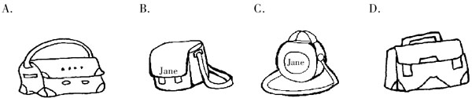
18. What colour is Jane's bag?
A. Black. B. Blue. C. Green. D. White.
19. What does Jane have in her bag?
A. Some books, pens and her ID card. B. Some books, pens and keys.
C. Some books, keys and pencils. D. Some books, keys and her ID card.
20. At what time is Jane going to the station tomorrow?
A. 8:15 a.m. B. 8:45 a.m. C. 9:15 a.m. D. 9:45 a.m.
IV. 短文理解（Passages） （共10小题，计10分）
A） 请听短文，根据你所听到的短文内容，选择能回答下列问题的最佳答案。短文读两遍。（答案涂在答题纸上）
21. Where is Betty from?
A. The USA. B. The UK. C. China. D. France.
22. Which is probably Betty's pet?
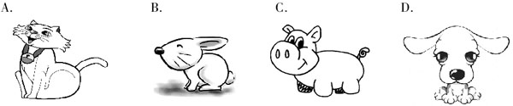
23. How does Betty go to school every day?
A. On foot. B. By car. C. By school bus. D. By bike.
24. What does Betty do after school?
A. She writes letters to her friends. B. She listens to the radio at home.
C. She plays with her pet. D. She goes to music classes.
25. How old is Betty's twin brother this year?
A. Seven. B. Eleven. C. Nine. D. Thirteen.
B） 非选择题：请听一段电话留言，根据你所听到的内容补全下面的留言条。留言读两遍。（答案写在答题纸上）
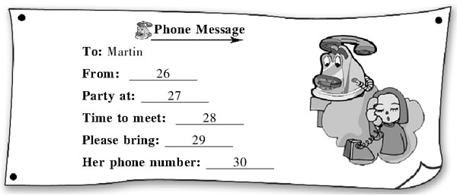
笔试部分（共七大题，计120分）
I. 选择填空（Vocabulary and structure） （共20小题，计20分）
A） 选出下列各题的最佳答案。（答案涂在答题纸上）
31. 国际奥委会的官方语言为 _________ 和 _________。
A. 英语； 法语 B. 德语； 英语 C. 德语； 法语 D. 英语； 汉语
32. 下列四组词中， _________ 均是双音节词。
A. student; beautiful B. thing; bedroom C. people; thirty D. answer; family
33. 在英语中，一般疑问句多用 _________ 来读，特殊疑问句多用 _________ 来读。
A. 升调； 升调 B. 降调； 降调 C. 降调； 升调 D. 升调； 降调
34. 缩略词“CBA”和“FIFA”分别与下面哪两项运动有关联？_________
A. volleyball; basketball B. basketball; football
C. baseball; tennis D. football; table tennis
35. 下列各句标点及书写均正确的是 _________。
A. Bruce says: “we're going to the hospital to see my grandfather．”
B. “Harry potter” is very popular among children.
C. I go swimming with uncle George on Sunday.
D. They are Tom Hanks, the actor; Mariah Carey, the singer.
36. There's _________ English boy playing _________ chess under the tree. _________ boy lives near here.
A. an; /; The B. an; the; The C. a; /; A D. a; a; A
37. Please give _________ some water. _________ are thirsty.
A. Tom and I; We B. me and Tom; They
C. Tom and me; We D. I and Tom; They
38. _________ come from _________. They speak _________. Their capital city is London.
A. Englishman; England; English B. Englishman; English; England
C. Englishmen; England; English D. Englishmen; English; England
39. The word “Morocco” has one “r” _________ two “c”s, _________ it doesn't have a “k” _________ an “a”.
A. or; but; and B. or; and; and; C. and; and; or D. and; but; or
40. Ms Johnson wants us _________ Exercise 1, but you let us _________ Exercise 4.
A. to do; to do B. to do; do C. do; do D. do; to do
41. Jerry swims very _________. He's a member of the _________ club.
A. fine; swims B. good; swimmer C. well; swimming D. nice; swim
42. — Can I borrow some books about the Internet?
— Certainly, but please give _________ soon.
A. back me B. them back C. me back D. back them
43. There are forty students in our class. Twenty-five are girls and _________ are boys.
A. other B. others C. the other D. the others
44. Jim and I go to school _________ eight thirty _________ every Saturday morning.
A. at; on B. in; in C. at; / D. on; in
45. Where would you see this notice — EVERYTHING HALF-PRICE?
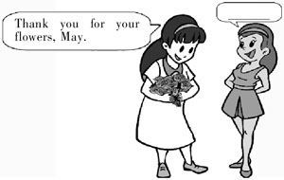
A. In a bank. B. At home. C. In a classroom. D. In a shop.
B） 情景对话。（答案涂在答题纸上）
46. A. I'm glad you like them.
B. No way.
C. Don't say that.
D. The same to you.
47. — I think she's from Canada.
— _________
A. Yes, all right. B. Yes, she's OK.
C. That's all right. D. Yes, that's right.
48. — Good afternoon, Mr Brown. _________
— Yes, he's at home. Come in, please.
— Thank you.
A. Where is Jim? B. Is Jim in?
C. Are you Kate's mother? D. Does Kate like to go out?
49. — Can you pass me the pens?
— _________
— Are they on the desk?
— Oh, no. I see. They are near the window.
A. Sorry, I don't know. B. Yes, here it is.
C. No, I can't. D. Sure, but where are they?
50. — What club does George want to join?
— The art club.
— _________
— I think so.
A. Can he paint well? B. Does he paint well or bad?
C. What can he do in the club? D. When does the club open?
II. 阅读理解（Reading comprehension） （共20小题，计30分；51—60小题每题１分，61—70小题每题２分）
A
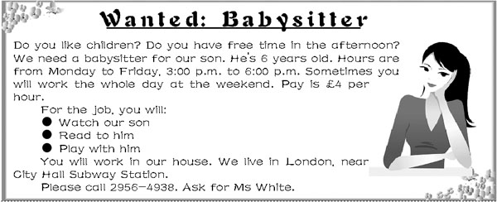
根据招聘广告内容，选择最佳答案。（答案涂在答题纸上）
51. The babysitter will work _________ hours from Monday to Friday altogether （总共）.
A. 6 B. 10 C. 15 D. 20
52. The babysitter will usually work _________.
A. in the morning B. in the afternoon C. in the evening D. at night
53. The babysitter will get _________ for working on Monday only.
A. ￡4 B. ￡8 C. ￡12 D. ￡16
54. What is NOT the babysitter's job?
A. Cleaning the child's house. B. Playing games with the child.
C. Reading books to the child. D. Taking care of the child.
55. Which of the following is TRUE?
A. The pay per hour is more at the weekend.
B. If you want to get the job, you must call Ms White.
C. The babysitter must work six days a week.
D. The child is 9 years old.
B
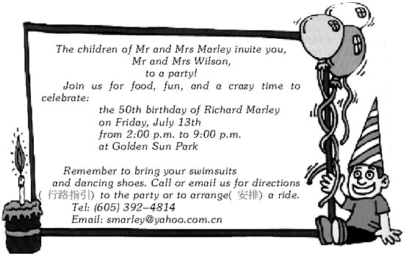
根据邀请函内容，选择最佳答案。（答案涂在答题纸上）
56. Who will be guests at the party?
A. The children of Mr Wilson. B. The Marleys.
C. Mr Wilson and his wife. D. Mr and Mrs Marley.
57. What will they have the party for?
A. New Year's Day. B. Mr Wilson's coming.
C. Christmas Day. D. Richard's birthday.
58. What will people do at the party?
A. Swim and dance. B. Ask for directions.
C. Buy a swimsuit. D. Ride a bike.
59. People without a car _________ to the party.
A. can ask for a ride B. can't go C. can write a letter D. can't ride
60. The invitation does not include （包括） _________.
A. an email address B. a time and a date C. directions D. a telephone number
C
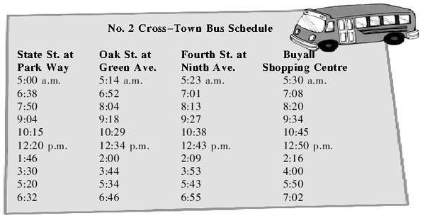
根据汽车时刻表内容，回答下列问题。（答案写在答题纸上）
61. How long does it take from State St. at Park Way to Buyall Shopping Centre by taking No. 2 Cross-Town bus?
62. What time does the first afternoon bus leave Fourth St. at Ninth Ave.?
63. How many times a day does No. 2 Cross-Town bus run between State St. at Park Way and Buyall Shopping Centre?
D
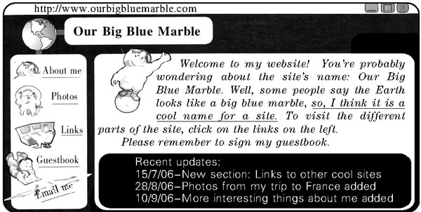
根据网页内容，完成下列各题。（答案写在答题纸上）
64. “Our Big Blue Marble” is another name for _________ according to the website.
65. The author （作者） added _________ in August, 2006.
66. Translate the underlined sentence （划线的句子） into Chinese, please.
E
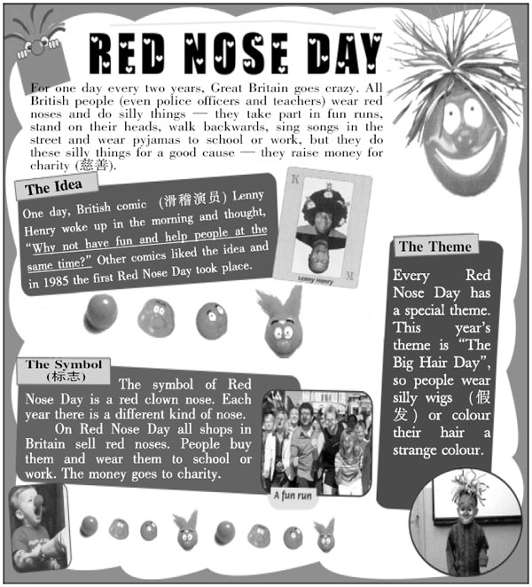
根据短文内容，完成下列各题。（答案写在答题纸上）
67. How often do British people celebrate Red Nose Day?
68. What do people do silly things on Red Nose Day for?
69. Please translate the underlined sentence into Chinese.
70. What's the theme of this year's Red Nose Day?
III. 完形填空（Cloze） （共20小题，计20分）
A） 从方框中选择适当的单词，并用其适当的形式完成短文，每词只能使用一次。其中有5个单词为多余选项。（答案写在答题纸上）
and, too, interest, year, wait, never, with, sport, be, also, but, a, the, look, great
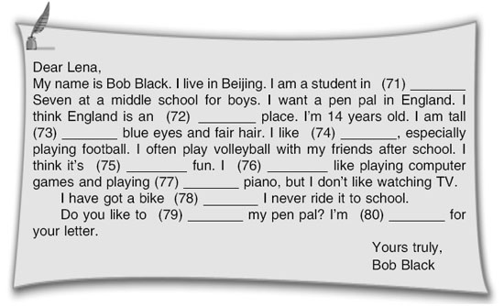
B） 用所给动词的适当形式填空。（答案写在答题纸上）
A little monkey, Jackie by name, (81) _________ (live) with his parents at the zoo. Every day a lot of children (82) _________ (come) up to his cage to give him some sweets. He loves sweets, but he can't eat any more. He (83) _________ (have) a bad toothache. The doctor comes (84) _________ (see) the little monkey. The doctor explains the monkey shouldn't eat sweets. They (85) _________ (be) bad for his teeth. The zookeeper (86) _________ (not, know) what to do. The doctor (87) _________ (tell) him to fix a special sign with (88) “_________ (not, give) Jackie any sweets!” on his cage. Jackie likes (89) _________ (eat) sweets very much, so he (90) _________ (try) to take down the sign, but he fails. He feels very sad now.
IV. 句式转换（Sentence pattern transformation） （共10小题，计10分）
按要求转换下列句式。每空一词。（答案写在答题纸上）
91. The film Ice Age II is great. （对划线部分提问）
_________ is the film Ice Age II?
92. How many members do you have in your club? (同义句转换)
How many members _________ _________ in your club?
93. My brother does his homework every day. (改为否定句)
My brother _________ _________ his homework every day.
94. Is that a knife or a pencil-box in your bag? (改为复数句)
Are those _________ or _________ in your bag?
95. Jeff likes to eat chicken very much. （对划线部分提问）
_________ _________ Jeff _________ to eat very much?
96. I have something to tell you. It's important. (合并成一句)
I have _________ _________ to tell you.
97. The nurse's parents usually go to work by bus. （用by car改为选择疑问句）
_________ the nurse's parents usually go to work by bus _________ by car?
98. Don't ask her to come into my room now. (改为肯定句)
_________ _________ to come into my room now.
99. There are some books on the desk. （改为一般疑问句）
_________ _________ _________ books on the desk?
100. The tennis rackets near the door are my friend Lucy's. （对划线部分提问）
_________ tennis rackets are your friend Lucy's？
V. 翻译（Translation） （共5小题，计10分）
根据提示将下列句子译成英语。（答案写在答题纸上）
101. 我想那个商店在这个时候已经关了。（think）
102. 安娜想更多地了解关于中国的历史。（know ... about）
103. 她看起来既年轻又漂亮。（look）
104. 格林一家经常呆在家里看电视吗？（at home）
105. 那块红色的手表和这块黑色的不一样。（same或different）
VI. 智力测试（IQ） （共5小题，计5分）
按要求完成下列各题。（答案写在答题纸上）
106. Read the dialogue. Can you guess the meaning of “on the cards” here? (You may answer it in English or Chinese.)
Chris: I think Simon will do well in this exam.
Ivan: I don't think it's on the cards. He plays all day.
107. Danielle travels around Europe （欧洲）. She likes Paris, but not London. She likes Frankfurt, but not Bonn. She likes Amsterdam, but not Barcelona. Do you think she will like St. Petersburg? Give your reason, please.
108. There is a connection （联系） between the house numbers and the names of the people who live there. Write the number of the last house, please.
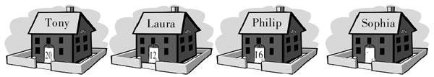
109. Four children, Pat, Sean, Alan and Sam, all have a birthday party today. In one year's time Sam will be the age Pat is now. Alan is half of Sean's age and is three years younger than Sam. Sam is 11 years old. What age will Alan be when Sam is 15 years old?
110. A little girl lives with her family on the tenth floor of a building. Every morning she goes down to the ground floor. She does not walk down, but she goes down in the lift （电梯）. Then she goes to school. She comes back from school in the afternoon and she gets into the lift on the ground floor. She goes up in the lift but she stops （停止） at the eighth floor. She gets out and walks up to the tenth floor. Why does she walk from the eighth floor?
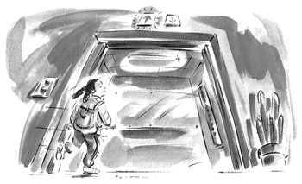
VII. 写作（Writing） （共2小题，计25分；A题10分，B题15分）
A
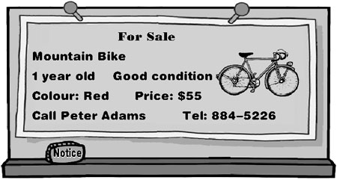
Peter is going to sell his mountain bike, because he wants to buy a motorbike. Tom is interested in buying a mountain bike. He got Peter's telephone number from a friend. He decides (决定) to phone Peter to get some information about the bike.
请根据所提供的信息并结合notice的内容，编写一段Tom与Peter之间的电话对话。（答案写在答题纸上）
要求：1. 将notice所给信息全部体现在对话中，并发挥想象适当拓展对话；
2. 条理清楚，意思连贯，语句通顺，标点正确，书写规范、清晰；
3. 不得少于50词。
B
请根据Mega Sports Centre的招贴内容，用英语为该运动中心写一份介绍广告。（答案写在答题纸上）
要求：1. 图片所提供的信息必须全部体现在广告中，运用多种句式；
2. 行文流畅，条理清晰，语句通顺，标点正确，书写规范、清晰；
3. 不得少于70词。
2006年全国中学生英语能力竞赛（NEPCS）初赛
初一年级组试题参考答案
听力部分（共四大题，计30分）
I. 听辨单词（Words）
1—5 CBDCA
II. 句子理解（Responses）
6—10 BCDAC
III. 对话理解（Dialogues）
A) 11—15 CABDB
B) 16—20 BCDBC
IV. 短文理解（Passages）
A) 21—25 BACDB
B) 26. Mary 27. The Grand Hotel 28. 6:30 p.m. 29. A friend 30. 724-5936
笔试部分（共七大题，计120分）
I. 选择填空（Vocabulary and structure）
A) 31—35 ACDBD
B) 36—40 ACCDB 41—45 CBDCD
C) 46—50 ADBDA
II. 阅读理解（Reading comprehension）
A) 51—55 CBCAB
B) 56—60 CDAAC
C) 61. 30 minutes. / Half an hour. 62. 12:43 p.m. 63. 10.
D) 64. the Earth 65. photos from his / her trip to France 66. 因此，我认为它是个很酷的网站名字。
E) 67. Every two years. 68. Raising money for charity. 69. “为什么不在娱乐的同时还帮助别人呢？” 70. The Big Hair Day.
III. 完形填空（Cloze）
A) 71. Year 72. interesting 73. with 74. sports 75. great 76. also 77. the 78. but 79. be 80. waiting
B) 81. lives 82. come 83. has 84. to see 85. are 86. doesn't know 87. tells 88. Don't give 89. eating / to eat 90. tries
IV. 句式转换（Sentence pattern transformation）
91. How 92. are there 93. doesn't do 94. knives; pencil-boxes 95. What does; like 96. something important 97. Do; or 98. Ask her 99. Are there any 100. Which
V. 翻译（Translation）
101. I think that shop is closed at this time of the day.
102. Anna wants to know more about Chinese history.
103. She looks both young and beautiful.
104. Do the Greens often stay at home watching TV?
105. That red watch isn't the same as this black one. / That red watch is different from this black one.
VI. 智力测试（IQ）
106. Likely / Possible (可能的).
107. Yes, I do, because she likes places that don't contain the letter “o”.
108. 19. (The number represents the alphabetic position of the first letter of the person's name. Sophia begins with the 19th letter of the alphabet.)
109. 12.
110. Because she is short, and she can't reach the number 10. The number 8 is the highest number she can reach, so she goes to the 8th floor and walks up to the 10th one.
VII. 写作（Writing）
A) One possible version:
Peter: Hello, 884-5226.
Tom: Hello, this is Tom. I'm interested in buying your mountain bike. How old is it?
Peter: It's one year old, and it's in good condition.
Tom: What colour is it?
Peter: It's red.
Tom: Why do you want to sell it?
Peter: Because I want to buy a motorbike.
Tom: How much is it?
Peter: I want $55 for it.
Tom: Oh, that sounds great!When can I come and see it?
Peter: Is tomorrow evening OK for you?
Tom: Yes, that's fine. Bye.
Peter: Bye.
B) One possible version:
Mega Sports Centre is the best sports centre in town. It is opposite Golden Lion Hotel in King Street. We have got friendly, experienced staff and lots of sports activities for everyone. There is a bowling alley, two basketball courts and two swimming pools. You can also play snooker and table tennis in Mega Sports Centre's games room. There is also Mega Café — a great place to relax at the end of the day.
For more information, call us at 882-5442.
一、 评分原则：
1．本题总分为: A） 10分； B）15分。按四个档次给分。
2．评分时，先根据文章的内容和语言初步确定其所属档次，然后以该档次的要求来衡量，确定或调整本档次，最后给分。
3．A部分作文词数少于50或多于100的， 从总分中减去２分; B部分作文词数少于70的, 从总分中减去2分。
4．如书写较差，以至影响交流，将分数降低一个档次。
二、 各档次的给分范围和要求：
第四档（很好）：A） 9—10分； B） 12—15分
完全完成了试题规定的要求，覆盖所有内容要点，符合英语表达习惯，应用了较多的语法结构和词汇，没有语法和词汇错误，具备较强的语言运用能力，完全达到了预期的写作目的。
第三档（好）：A） 6—8分； B） 9—11分
完成了试题规定的要求，应用的语法结构和词汇能满足题目的要求，符合英语表达习惯，基本没有语法和词汇错误，达到了预期的写作目的。
第二档（一般）：A） 4—5分； B） 5—8分
未恰当完成试题规定的要求，漏掉内容要点，未描述清楚主要内容，写了一些无关内容，有语法和词汇错误，影响了对写作内容的理解，信息未能清楚地传达给读者。
第一档（差）：A） 1—3分； B） 1—4分
未完成试题规定的要求，明显遗漏主要内容，写了一些无关内容，语法结构单调，词汇有限，有较多语法和词汇错误，影响对写作内容的理解，信息未能传达给读者。
0分
未能传达给读者任何信息，没有内容或内容太少，无法评判，写的内容均与所要求内容无关或所写内容无法看清。
2006年全国中学生英语能力竞赛（NEPCS）初赛
初一年级组试题听力部分录音原文
Part I. Words
Listen to the sentences. Choose the word you hear in the sentence. Each sentence will be read only once.
1. Come to Mr Smith's clothing sale.
2. Sally's aunt gives her twelve pencils.
3. Polly's family are always happy to help.
4. What time is the talk show tonight?
5. Don't speak with your mouth full.
Part II. Responses
Listen to the sentences. Choose the right response to each sentence. Each sentence will be read only once.
6. Would you please give the book to me?
7. How's your English class?
8. Excuse me. Can I sit here?
9. Do you know the man near that house?
10. Do you watch TV a little or a lot?
Part III. Dialogues
A) You will hear five mini-dialogues. Choose the best answer to each question according to the dialogue. Each dialogue will be read twice.
11. M: Look, Kate. What's that under the desk?
W: It's a watch. It's a new one. Is it yours, Jack?
M: No. Mine is old. Whose is it?
W: I think it's Paul's. Let's go and ask him.
12. M: Look at all the shoes.
W: I like those black ones.
M: Where?
W: Next to the red ones.
M: Oh, between the red ones and the brown ones?
W: No, behind the blue ones.
13. W: Hello.
M: Hello, Susan. This is Mike. Would you like to come to my birthday party?
W: I'd love to. Your birthday is on Wednesday, isn't it?
M: Yes, it is, but I'm having the party on Thursday. It's in my house.
W: That sounds great. Thank you.
14. W: I want to buy a present for Sue.
M: What about a pencil-box?
W: Good idea!This one is nice. It's small and she likes green.
M: I think she will like that big orange one.
W: No, this is better. I'll take the small one.
15. M: This is a beautiful place. Let's come here again tomorrow!
W: Don't we have to go shopping tomorrow?
M: We can do that in the morning, and come here in the afternoon.
W: OK. Let's bring Joe and Linda with us.
B) Listen to the following dialogue. Choose the best answer to each question according to the dialogue. The dialogue will be read twice.
M: Can I help you?
W: Yes, I hope so. I left my bag on the bus this morning.
M: Which bus?
W: Oh, the 8:40 bus from London.
M: What does the bag look like?
W: It's a middle size white bag. Ah, it's a round one.
M: Any marks on it?
W: Em... yes, my name is on it.
M: What's your name?
W: Jane Smith.
M: OK, Jane. What do you have in your bag?
W: Er... all my books from school, and some pens. Here is my ID card, so I didn't lose it. Oh, my keys are in it, too.
M: OK, can you come down to the station at a quarter past nine tomorrow morning? You can look at what we've got here.
W: That's fine. Thank you. Bye.
M: Bye.
Part IV. Passages
A) You will hear a passage. Choose the best answer to each question. The passage will be read twice.
I have a pen pal named Betty. She often writes to me from England. She lives in a tall building in the city. Every morning, she has to make her bed and feed her cat. She never walks to school. She always takes the school bus. After school, she usually waits for her twin brother. They have to take another bus to go to their music lessons. My pen pal loves music.
Today is her birthday. I have a present for her. She's eleven years old this year.
B) Listen to the phone message. Complete the form of the phone message. The message will be read twice.
Hi! This is Martin. I'm sorry I can't speak to you right now. Please leave a message.
Hello, this is Mary speaking. I am calling to tell you that the party tonight is at the Grand Hotel. That's G-R-A-N-D. It's near Ely's ice cream shop. I think you know where it is, right? I'll meet you there at half past six. Besides, bring one of your friends, please. And call me back if you have any questions. My phone number is 724-5936. Bye.

声明：本资料由 考试吧（Exam8.com） 收集整理，转载请注明出自 http://www.exam8.com
服务：面向较高学历人群，提供计算机类，外语类，学历类，资格类，会计类，工程类，医学类等七大类考试的全套考试信息服务及考前培训.

