白湖镇顺港中学七年级英语竞赛试题
考试时间为100分钟，满分100分。
班级：__________姓名：___________得分：_____________
一、单项填空 从每小题四个选项中，选出可以填入空白处的最佳答案，将最佳选项的字母编号填写在题号前括号内。（本大题共14小题，每小题1分，共14分。）
( )1. Linda is my mother’s sister, so she is my ______.
A. sister B. cousin C. aunt D. uncle
( )2. This _____ my room. There _____ a clock and some books in the bookcase.
A. are, is B. is, are C. are, are D. is, is
( )3.--- Where are _______ keys? --- ______ are in the drawer.
A. his, It B. my, They C. her, my D. she, They
( )4.--- Are you Han Mei? --- ______. I am Wei Hua.
A. Yes, I am B. No, I am C. Yes, I’m not D. No, I’m not
( )5.--- Does he play sports?
--- No, _____. He only watches them______ TV.
A. he does, on B. he does, in C. he doesn’t, on D. he doesn’t, in
( )6.---Do you have _______ basketball? ---Yes, I do.
A. a B. an C. the D. /
( )7.--- __________ does Tom have in the morning? --- Math and Chinese.
A. What class B. What’s your favorite subject
C. How many class D. What subject
( )8.For dinner, Tom likes ______.
A. hamburgers, salad, and oranges B. chicken, tomatoes, French fries
C. eggs, bananas, and apple D. French fries, sofa, vegetable
( )9.--- Draw a map on the blackboard, Tom? --- ________.
A. Yes, please B. That’s all right C. All right D. Thanks
( )10.--- Can I help you?
--- ______________.
A. Yes, please B. Thank you C. OK D. You are welcome
( )11.September is the ________ month of a year.
A. nine B. nineteen C. nineth D. ninth
( )12.--- How much is this T-shirt?
--- Ninety _________.
A. dollar B. yuan C. yuans D. cent(美分)
( )13.There are _________ days in May.
A. twenty-eight B. thirty-one C. twenty-nine D. thirty
( )14.The man doesn’t know how to ________ this word in English.
A. speak B. say C. tell D. talk

二、请把下列单词中的十二个按要求归类（本大题共12小题，每小题0.5分，共6分）
difficult science interesting January Tuesday hamburger July
September broccoli math Thursday history Friday relaxing
15.Adjectives ___________ __________ ___________
16.Months ___________ __________ ___________
17.Weekdays ___________ __________ ___________
18.Subjects ____________ ___________ ____________

三、给下列对话排排序。（每空1分，共10分）
In an English corner(英语角), two boys are talking in English.
A: What's your favorite sport?
B: I am thirteen years old.
C: Ping-pong.
D: My name is David. How old are you, please?
E: Good evening.
F: Yes, I do. Deng Yaping, Liu Guoliang and Kong Linghui.
G: Deng Yaping is very famous. She is well-known all over the world…
H: I am twelve. What about you?
I: Ping-pong is good. That's a popular sport. Then do you have your favorite players（运动员）?
J: Good evening. My name is Tom. What's your name, please?
19.正确的顺序是：____-_____-_____-_____-_____-_____-_____-_____-_____-____

四、完形填空 通读下面短文，掌握其大意，然后在各小题所给的四个选项中选出一个最佳答案，将其字母填写在题号前的括号内。（本大题共10小题，每小题2分，共20分。）
Tome is a boy 20 fourteen. He is a middle school student . He 21 very hard . He is a good student . 22 he gets up at 6:30 in the morning . 23 that he washes his face , brushes his teeth and then 24 out to do morning exercises . He 25 breakfast at about 7:00 . He goes to school at 7:30 26 his bike .Classes 27 at 8:00 . They have six classes a day , four in the morning and two in the afternoon . Classes are over at four . After school he 28 baseball on the playground . At about five he comes home . He has supper at six . After supper he 29 homework .
( )20. A．at B．of C．for D．in
( )21. A．studies B．study C．learn D．studys
( )22. A．Then B．Usually C．Because D．After
( )23. A．After B．Then C．Before D．At
( )24. A．go B．come C．goes D．going
( )25. A．have B．take C．make D．has
( )26. A．in B．on C．at D．by
( )27. A. are over B．are begin C．begin D. begins
( )28. A．plays the B．has C．makes D. plays
( )29. A．do B．does C．have D. take

五、阅读理解 阅读下列短文，并做每篇短文后的题目。从每小题所给的四个选项中，选出能完成所给句子的最佳答案，将其字母填写在题号前的括号内。（本大题共10小题，每小题2分，共20分。）

A

Hello, everyone! It’s that time of year again! Hualin’s fantastic sale! You name it, and we have it at a very good price.
Do you like sweaters? Do you like them at low prices? We have sweaters in all colors at 50 yuan each! Do you need a bag for sports or school? We have great bags for just 6 yuan! For young boys and girls, we have T-shirts in red, green, yellow, orange, blue and black for only 15 yuan! And socks in all colors for just 1 yuan! And that’s not all. Can’t believe it? Come down to Hualin and see by yourself!

( )30.This article is .
A. a story(故事) B. an ad
C. about family D. about buying and selling
( 31.What is the Chinese for the word “fantastic”?
A. 便宜的 B. 稀奇古怪的 C. 极好的 D. 昂贵的
( )32.You want to buy a sweater and a T-shirt. How much will you have to pay?
A. ¥51 B. ¥21 C. ¥56 D. ¥65
( )33.You want some black socks. Can you buy them here?
A. No, I can’t. B. Yes, I can C. No, I can. D. Yes, I can’t.
( )34. Which sentence is right according to (根据) the article?
- There are no green sweaters.
- Young boys and girls like T-shirts very much.
- The T-shirts in Hualin are for young boys and girls.
- Only the things in the ad are cheap.

B
Green Trees Gym(体育馆)
Swimming Mon. ~ Sun. 8:00 a.m. ~ 8:00 p.m.
Basketball Sat. ~ Sun. 8:00 a.m. ~ 6:00 p.m.
Volleyball Mon. ~ Sat. 10:00 a.m. ~ 6:00 p.m.
Aerobics（健身操） Mon. ~ Sun. 6:00 a.m. ~ 9:00 p.m.
Tel: 6227225
E-mail: greentrees@yahoo.com

Red Apples Gym
Swimming Mon. ~ Fri. 6:00 a.m. ~ 6:00 p.m.
Basketball Mon. ~ Sun. 8:00 a.m. ~ 6:00 p.m.
Volleyball Mon. ~ Sun. 8:00 a.m. ~ 6:00 p.m.
Aerobics Mon. ~ Sun. 8:00 a.m. ~ 9:00 p.m.
Tel: 6589417
Welcome You!
根据上面广告选择最佳答案。
( )35. I want to go swimming on Sunday. Where can I go? ___________
A. Green Trees Gym. B. Red Apples Gym.
C. Both Green Trees Gym and Red Apples Gym. D. You can’t go swimming on Sunday.
( )36 . I want to play basketball on Monday morning. Where can I go? _________
A. Green Trees Gym. B. Red Apples Gym.
C. Both Green Trees Gym and Red Apples Gym. D. Green Apples Gym.
( )37 . I play volleyball at 9:00 every morning. Where can you find me? ___________
A. Green Trees Gym. B. Red Apples Gym.
C. Both Green Trees Gym and Red Apples Gym. D. At home.
( )38. I do aerobics every afternoon. So you can call me at 6589417. Do you know where I’m going to be(将会在)? _________
A. At Green Balls Gym. B. At Red Apples Gym.
C. in the school. D. On the playground.
( )39. Which gym accepts (接受) mail from computer? ___________
A. Green Balls Gym. B. Red Apples Gym.
C. Green Apples Gym. D. Red Trees Gym.

六、读写综合(本大题分A B两部分，共30分)
A)请仔细阅读下面的信，然后填写表中要求的内容(10分)和回答问题(10分)。(每小题2分，本题共20分)
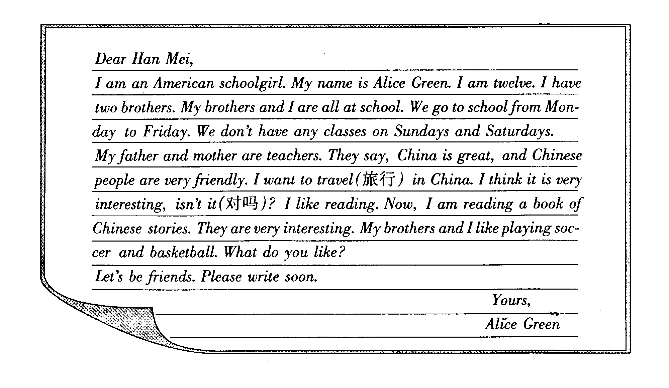

Information (信息)Card
40.Your Pen pal’s name
41. Sex(性别)
42. Age
43. School day
44. Hobbit (爱好)

Questions: （作完整回答）
45. How many people are there in Alice Green’s family?

___________________________________________________________________
46. What do her parents do?

___________________________________________________________________
47. Where does she want to travel?

___________________________________________________________________
48. What does Alice like about Chinese stories? (Alice认为中国故事怎么样？)

___________________________________________________________________
49.What do her brothers like?

___________________________________________________________________

B）假如你是Han Mei，请你参照阅读材料中的相关信息，给Alice回一封信，介绍你
和你的家人，字数在50字左右。(共10分)
Dear Alice Green,
__________________________________________________________________________
__________________________________________________________________________
__________________________________________________________________________
__________________________________________________________________________
__________________________________________________________________________
__________________________________________________________________________
Yours,
Han Mei

七年级英语竞赛试题参考答案
一. （本大题共14小题，每小题1分，共14分。）
1.C 2.D 3.B 4.D 5.C 6. A 7. D 8. A 9. C 10. A
11.D 12.B 13.B 14.B
二. （本大题共12小题，每小题0.5分，共6分）
15. difficult, interesting, relaxing 16. January, July, September
17. Tuesday, Thursday, Friday 18. science, math, history
三.（每空1分，共10分）19. E- J- D- H- B-A-C-I-F-G
四. （本大题共10小题，每小题2分，共20分。）
20.B 21.A 22.B 23.A 24.C 25.D 26.B 27.C 28.A 29.B
五. 本大题共10小题，每小题2分，共20分。）
A） 30.B 31.C 32.D 33.B 34.C
B） 35.A 36.B 37.B 38.B 39.C
六(本大题分A B两部分，共30分)
A) (每小题2分，本题共20分)
Information Card:
40.Alice Green
41.girl
42.twelve
43.from Monday to Friday
44.reading, playing soccer and basketball
Questions:
45. There are five people.
46. They are teachers.
47. She wants to travel in China.
48. (She thinks) they are very interesting.
49. Her brothers like playing soccer and basketball.
B)短文写作 (共10分)。
略 （注：字数明显不足，酌情扣分。）

声明：本资料由 考试吧（Exam8.com） 收集整理，转载请注明出自 http://www.exam8.com
服务：面向较高学历人群，提供计算机类，外语类，学历类，资格类，会计类，工程类，医学类等七大类考试的全套考试信息服务及考前培训.

